Winch control manual

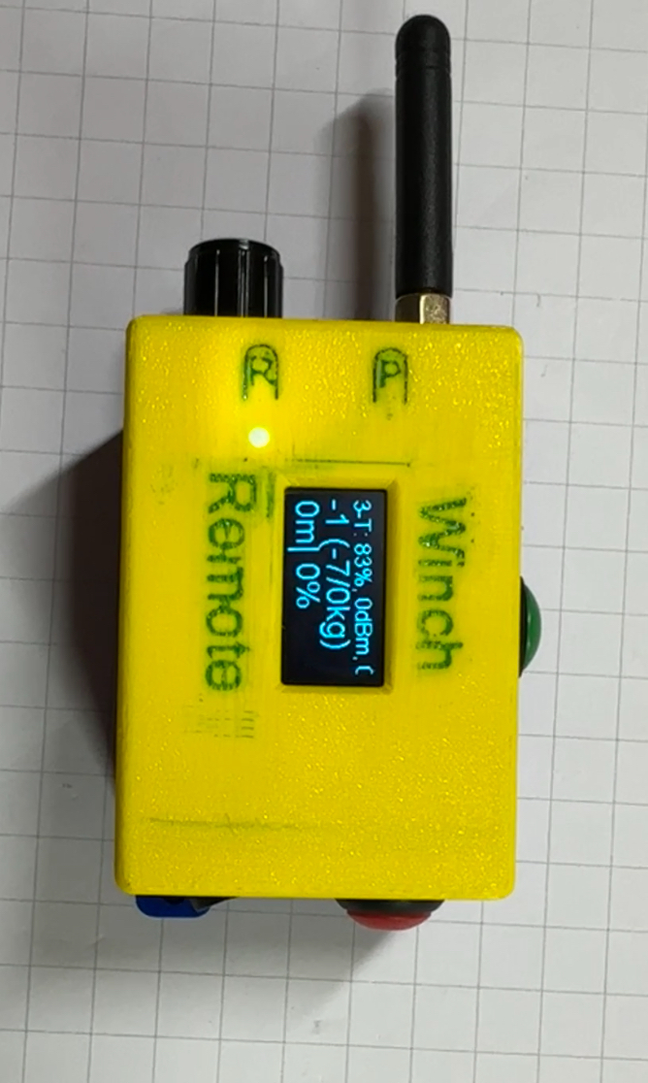

BTN UP

BTN DOWN

Setup Switch

Lora Antenna

Switch

ON / OFF

